## Overview

In this activity, you will create 2 interactions using Webflow.

## Instructions

**Interaction #1**

1. Using one of your existing projects, add a new page.
   1. 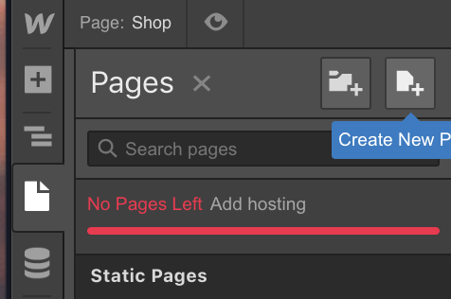
   2. Note: You may need to delete a page or a project.
2. Before we create an interaction, we need to make some content to interact with.
   1. 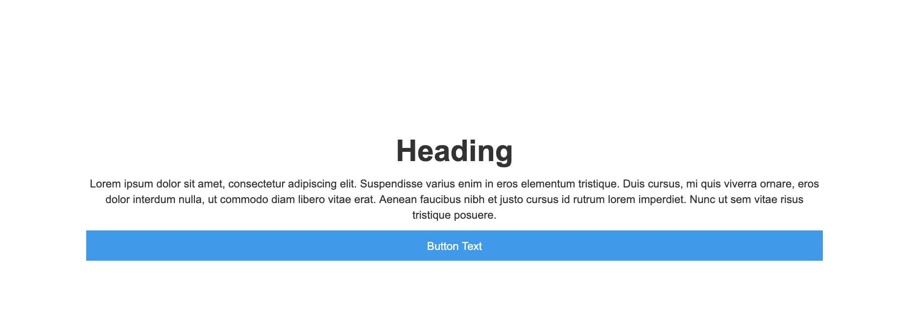
3. On the page, drag a section from the elements panel onto the canvas.
   1. Give it a height of 500px.
4. Inside the section, add a container.
   1. Insider the container add a:
      1. Heading
      2. Paragraph
      3. Button
   2. Your navigator should look like:
      1. 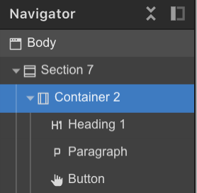
   3. Set the container height to 100%.
   4. Set the container to display FLEX.
      1. Make the flex VERTICAL.
      2. Make Align items set to STRETCH.
      3. Justify the content CENTER.
      4. 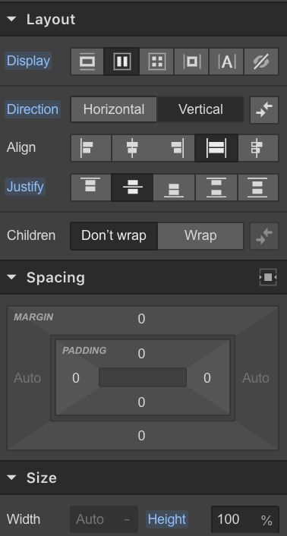
   5. Stay on the container class and switch over to the interactions tab:
      1. 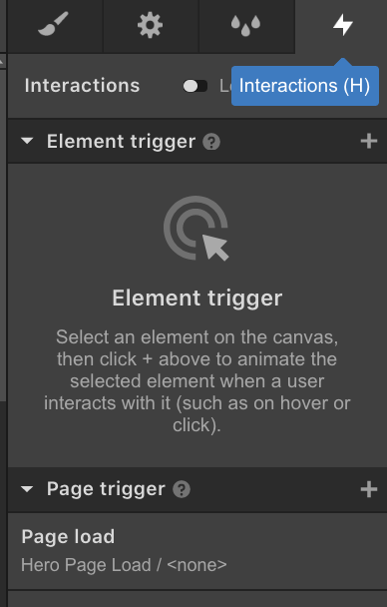
   6. Under the Page Tigger panel click the + button and select PAGE LOAD:
      1. 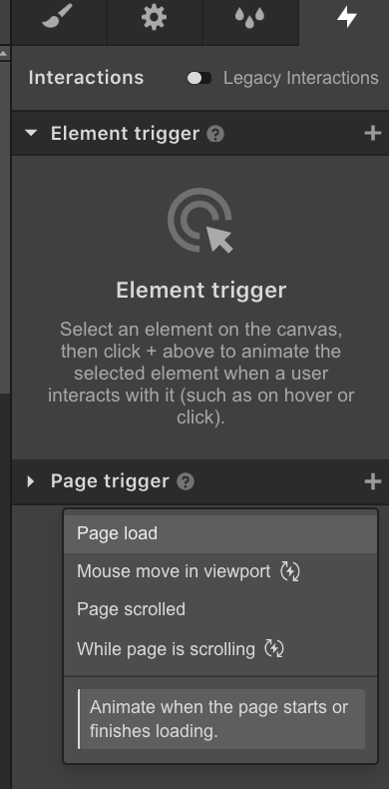
   7. On the next screen select new timed animation:
      1. 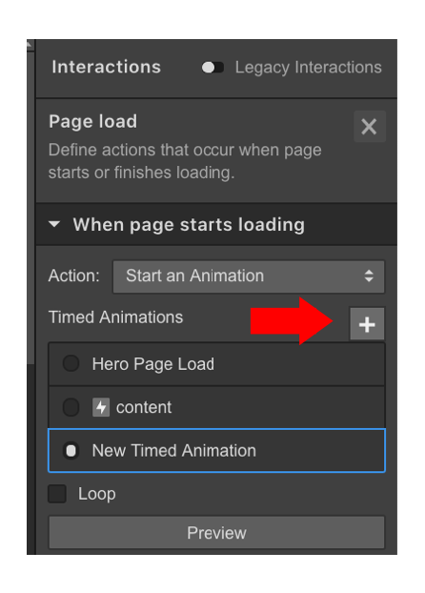
   8. Give your animation a name:
      1. 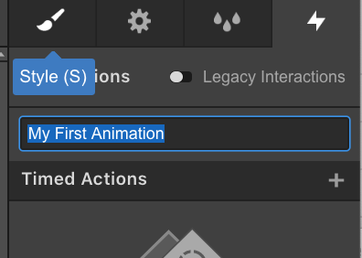
   9. Make sure you have the container class selected.
      1. From the interaction panel, press the plus button next to TIMED ACTIONS.
         1. Select MOVE.

|  |  |
| --- | --- |
|  |  |

* + 1. Set MOVE to 100 px down the Y-AXIS.
       1. You can move the shape using the move panel at the bottom right-hand corner of the screen.

|  |  |
| --- | --- |
|  |  |

* + 1. Go back to the timed actions header at the top of the page.
    2. Press the plus button again.
       1. 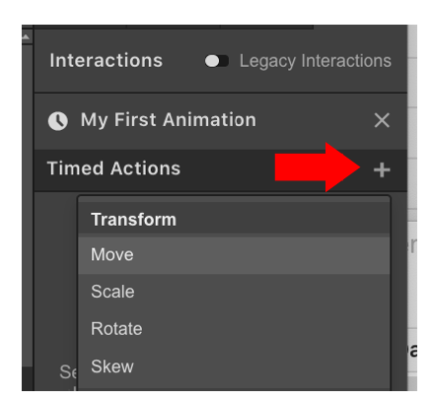
       2. Create another transform and select MOVE
    3. Your interactions panel should look like:
       1. 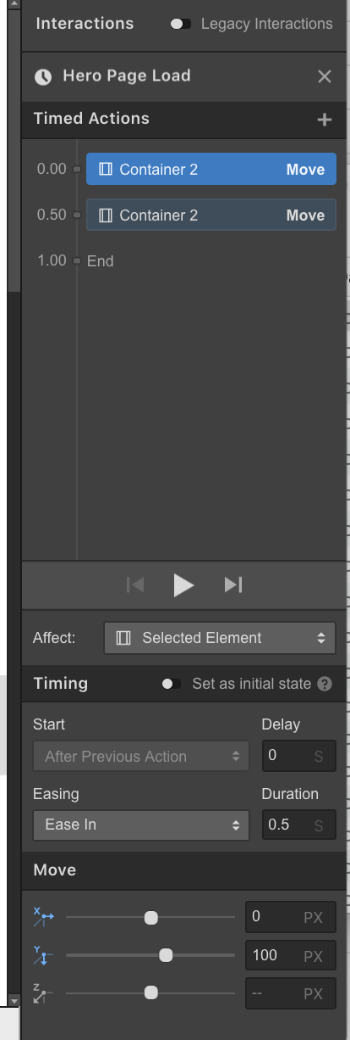
    4. Set the Move settings to between 0px to 20px.
       1. 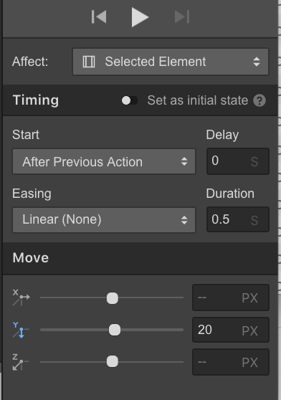
    5. Press play.
       1. 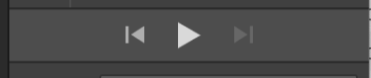
    6. Your animation should play.
       1. 

**Interaction #2**

1. Feel free to create a custom interaction if you’d like.
2. Select the button in your container.
   1. Set the width to 200px and set the align to center.

|  |  |
| --- | --- |
|  |  |

1. Select the interaction panel and under ELEMENT TRIGGER, press the plus button.
   1. Select MOUSE HOVER.
   2. 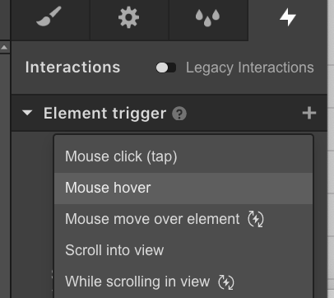
2. Set the ACTION to POP.
   1. 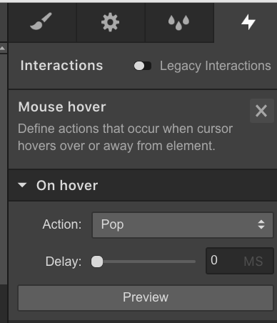
3. If you want this interaction to apply to every button on the page, you can create a class.
   1. Under TRIGGER SETTINGS toggle CLASS.
   2. 